

**The Michael Price Student Investment Fund**

***The Leonard N. Stern School of Business – New York University***

***Annual Report***

***February 29, 2020***



**NYU Stern’s Michael Price Student Investment Fund**

**A Family of Funds Managed by**

**NYU Stern School of Business MBA Students**

**What is the Michael Price Student Investment Fund?**

With $2.1 million currently under management, the Michael Price Student Investment Fund (“MPSIF” or “the Funds”) is a family of funds managed directly by NYU Stern MBA students. The Funds, part of the overall NYU endowment, were established in 1999 through a generous gift from Michael Price, Managing Partner, MFP Investors, LLC and former Chairman of Franklin Mutual Series Funds.

**WHAT IS UNIQUE ABOUT MPSIF?**

The Michael Price Student Investment Fund provides Stern MBA students with hands on experience managing real Funds with significant assets. In addition, the Funds are required to pay an annual 5% dividend to the University of Oklahoma Price School of Business, Mr. Price’s undergraduate alma mater. This dividend assists students with their tuition and living expenses so they can attend summer classes at Stern. Additionally, MPSIF maintains a transparent record of our performance and classroom activities.

**What is the portfolio composition?**

For diversification purposes, MPSIF is divided into three equity Funds—Growth, Value, and ESG—and one Fixed Income Fund. While each sub-Fund has its own performance benchmark (Russell 1000 Growth Index, Russell 1000 Value Index, S&P 500, and the Vanguard Total Bond Index, respectively), MPSIF’s primary goal is to deliver overall positive returns. Prior to March 2018, MPSIF also operated a Small Cap Fund, which was dissolved, and the proceeds disbursed pro rata across the other sub-funds.

**What Role do Stern MBA Students Play in Managing the Funds?**

Students must go through a competitive process to become a portfolio manager or analyst with the Funds, which is the basis of Stern’s “Managing Investment Funds” course. Stern MBAs must apply to this course, and demand has always exceeded available spots. About 40 students enroll each year and are then responsible for all Fund activities—screening and evaluating stocks, preparing and presenting pitches for buy and sell recommendations and strategizing on broader portfolio issues as they relate to sectors allocation. For the Fixed Income Fund the primary role of analysts is to make tactical allocation recommendations and decisions based on market outlook and economic analyses among various product sectors.

**Executive Committee – Fall 2019**

|  |  |
| --- | --- |
| President | Raymon Halim |
| Co-Portfolio Managers, ESG Fund | Lance He, Zhipeng (Leo) Liu |
| Portfolio Manager, Fixed Income Fund | Siddhartha Kaparthy, Daniel Jaw |
| Co-Portfolio Managers, Growth Fund | Michael Lee, Ryan Snope |
| Co-Portfolio Managers, Value Fund | Andrew Hanna, Peng Ser |
| Faculty Advisor | Professor Anthony Marciano |

**Executive Committee – Spring 2020**

|  |  |
| --- | --- |
| President | Bryce Mendes |
| Co-Portfolio Managers, ESG Fund | Jiang Li, Dimitrios Niarchos |
| Co-Portfolio Managers, Fixed Income Fund | Beatriz Abreu, Yelena Nemenko |
| Co-Portfolio Managers, Growth Fund | Beatriz del Rio, Riazul Islam |
| Co-Portfolio Managers, Value Fund | Samuel Simpson Dore, Helena Duffee |
| Faculty Advisor | Professor Anthony Marciano |

**Management Advisory Council**

John Apruzzese, CIO, Evercore Wealth Management

Robert Brown, Founding Partner, Atlas Impact Partners

Nomi Ghez, Co-founder of Circle Financial Group, retired Partner and Managing Director, Goldman Sachs

Randall Haase, Managing Director and Portfolio Manager, Loeb Partners

Jared Mann, Managing Director, Neuberger Berman

Richard Saperstein, Managing Partner/Principal/Senior Portfolio Manager, Treasury Partners

Michael Weinberg, Head of Hedge Funds & Alternative Alpha, APG Asset Management

Mitchell Williams, Head of Securities, Wafra Investment Advisory Group

*Ex Officio Members*

Stephanie Pianka, Vice President, Financial Operations & Treasurer, New York University

Kathleen Jacobs, Chief Investment Officer, New York University

**Board of Advisors**

Dean Raghu Sundaram, Stern School of Business, New York University

Duane R. Stock, Professor of Finance, Price College of Business, University of Oklahoma

Michael F. Price, Benefactor

Martin Gruber, Emeritus Professor of Finance, Stern School of Business

Richard Levich, Professor of Finance, Stern School of Business

Arthur Zeikel, Adjunct Professor of Finance, Stern School of Business

**Resource Faculty**

Aswath Damodaran, Professor of Finance, Stern School of Business

Martin Gruber, Professor (Emeritus) of Finance, Stern School of Business

Edward Kerschner, Adjunct Professor of Finance, Stern School of Business

Fred Renwick, Professor (Emeritus) of Finance, Stern School of Business

Matthew Richardson, Professor of Finance, Stern School of Business

# TABLE OF CONTENTS

LETTER FROM THE FACULTY ADVISOR …………………………………………………………………...…………. 1

LETTER FROM THE PRESIDENT …………………………………………………………….……….…….……………. 3

THE MICHAEL PRICE STUDENT INVESTMENT FUND

REVIEW OF OPERATIONS ……………………………………………………………………………….……………………………... 4

BENCHMARK INDEX DESCRIPTION ………………………………………………………………………………………………… 6

ASSET ALLOCATION …………………………………………………………………………………………………………………… 7

THE GROWTH FUND

MESSAGE FROM THE PORTFOLIO MANAGERS ………………………………………………………………………………….. 8

DISCUSSION OF PERFORMANCE ……………………………………………………………………………………………………. 10

ASSET ALLOCATION ………………………………………………………………………………………………………………….. 13

HOLDINGS PROFILE …………………………………………………………………………………………………………................ 15

INVESTMENT STYLE AND STRATEGY ……………………………………………………………………………………………… 16

THE VALUE FUND

MESSAGE FROM THE PORTFOLIO MANAGERS ………………………………………………………………………………… 17

DISCUSSION OF PERFORMANCE …………………………………………………………………………………………................ 19

ASSET ALLOCATION …………………………………………………………………………………………………………………… 22

HOLDINGS PROFILE ……………………………………………………………………………………………………………………. 23

INVESTMENT STYLE AND STRATEGY ……………………………………………………………………………………………… 24

THE FIXED INCOME FUND

MESSAGE FROM THE PORTFOLIO MANAGERS ………………………………………………………………………………….. 25

DISCUSSION OF PERFORMANCE ……………………………………………………………………………………………………. 27

ASSET ALLOCATION ……………………………………………………………………………………………………………….….. 28

HOLDINGS PROFILE …………………………………………………………………………………………………………………… 29

INVESTMENT STYLE AND STRATEGY ……………………………………………………………………………………............... 30

THE ESG FUND

MESSAGE FROM THE PORTFOLIO MANAGERS ………………………………………………………………………………….. 31

DISCUSSION OF PERFORMANCE ……………………………………………………………………………………………………. 32

HOLDINGS PROFILE .……………………………………………………………………………………………………………….….. 33

SECTOR ALLOCATION .……………………………………………………………………………………………………………….. 34

INVESTMENT STYLE AND STRATEGY ……………………………………………………………………………………............... 35

FUND MANAGEMENT

THE EXECUTIVE COMMITTEE ……………………………………………………………………………………………………….. 36

THE GROWTH FUND …………………………………………………………………………………………………………….…….. 38

THE VALUE FUND ………………………………………………………………………………………………………………….….. 42

THE FIXED INCOME FUND …………………………………………………………………………………………………………… 44

THE ESG FUND ………………………………………………………………………………………………………………………… 45

# Letter from the Faculty Advisor

I am pleased to introduce the Annual Report for the Michael Price Student Investment Fund (MPSIF) for the fiscal year ending February 29, 2020 – celebrating the 20th anniversary of the Fund. Unfortunately, we present the figures at the most challenging time of my lifetime – where a pandemic threatens the physical health of the nation and world while the social response of shelter-in-place simultaneously threatens our financial health. The economic meltdown in March predated the students’ Spring break by mere days. While managing their abrupt return home, preparing for remote education, and dealing with the uncertainties of this tragic environment, they were tasked with examining their portfolios with a scalpel rather than a sledgehammer. While the simplistic worldview of computer algorithms and the irrational emotions of humans likely offered some opportunities to find positions that would soon likely correct, this similarly likely would only last for an instant. The students were not positioned in my opinion – given their competing responsibilities -- to fully take advantage.

As of May 5th, the overall Fund holds almost exactly $1.9 million under management – still a bit more than when the Fund was begun 20 years ago -- and was recently able to pay our 20th dividend in the amount of $91,100 to enable students from the University of Oklahoma to visit and take classes at the NYU campus. Clearly with the current shut down of our physical campus, we need to consider how to approach this program for this year. Overall, we have now paid about $2 million in total dividends over the life of the Fund – more than the original generous donation by Mr. Price.

From the course’s perspective, one positive development is the increase in interest in the course as we have recently received twice as many applications. As students navigate the complex world in its current state, there exists the increasing possibility of a significant role for active investing.

Let us examine performance this term, which unlike last term, has not been as strong as demonstrated by the six-month return of -0.29%, compared to the blended benchmark of 2.04% -- for a relative underperformance of 2.33%. The overall performance since inception is now 5.37% annualized as compared to the blended benchmark’s 5.80% for an underperformance of 43 bps. The annual return being greater than the 5% dividend has allowed the Fund to pay the annual dividend and maintain a slight growth of assets. As of the time of this Report, the assets under management has dropped to almost exactly $1.9 million resulting in the annualized performance of approximately 5% – about 30 bps below the S&P 500 benchmark over the same time horizon. This seemingly low metric results from the Fund suffering through three financial crashes over its 20 year life: the dot com bust of 2000, the financial crisis of 2008, and the Covid-19 melt down today. The three equity subfunds each underperformed in varying degrees and the portfolio managers discuss the details in their sections of this Report. The exception was Fixed Income, which earned a 2.48% return and overperformed its benchmark by 51 bps.

We keep in mind that this slight underperformance is paired with an invaluable learning experience for the students who get to partake in experiential learning regarding investment management. We must acknowledge this special opportunity to perform the functions of investing part of the schools’s endowment – one that is not offered at any other top business school program. I am confident the mistakes made here are ones the students are less inclined to make in their future investment careers.

There is no more special element to the course that the students value more than the involvement of our wonderful Management Advisory Council (MAC). This term we were visited either physically or more recently remotely through Zoom by six of the now eight members. And especially at a time like this, their insightful input in all areas not just limited to investing advice is immensely appreciated by me personally and of course the students themselves. I am extremely happy that we have welcomed two new members at this point to the MAC in the areas of ESG – Rob Brown of Atlas Impact and Jared Mann of Neuberger Berman. This subfund remains the smallest of the equity subfunds, but we plan on growing it next term as their number of positions continues to grow.

It is a challenging time naturally for the Fund, and certainly for the world at large as we navigate the pandemic and the appropriate response. On the other hand, it appears that times like these open up the possibility that there is an increased role for investment advice. I believe this greater curiosity has contributed to the increase in applications to this unique course. This was a great concern noted previously but of course is now overcome by other concerns. Regardless, I have really enjoyed navigating this time with this group of students and am excited about the Fund’s future.

Anthony Marciano

Faculty Advisor, MPSIF

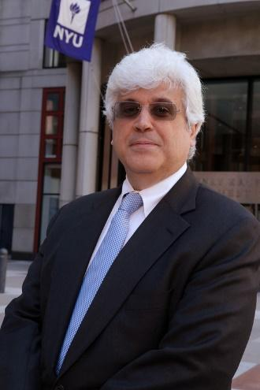

# Letter from the President

Spring 2020 has been a tumultuous time for the markets, with the macroeconomic backdrop of the COVID-19 pandemic and global political tensions. We began the period in September 2019 with a cash position at 10.32% of AUM—which was subsequently reduced to 4.66%—as students continued to pitch promising investment opportunities and cash holdings were shifted into ETF’s.

MPSIF returned -0.29% over the past six months, slightly underperforming benchmarks across the Growth, Value, and ESG sub funds. On the other hand, Fixed Income slightly led its benchmark and returned 2.48% over the period. The freeze in economic activity that has developed throughout the semester in response to the virus situation has created a sharp shock to growth expectations. Amidst this uncertainty, it has proven to be a challenging yet exciting time for students to search for attractively priced investments across the sub funds.

Students have shown dedication to the class by developing thoughtful investment theses and backing up their views with in-depth, much-deliberated valuations. We are grateful too for the time and insight from the guest speakers, who provided insightful perspectives that often became the cornerstones for our investment theses.

Beyond investment performance, MPSIF has seen significant growth over the past 6 months. This semester saw the continued development of the ESG Fund—now in its third semester. Additionally, further time and consideration was put into our sub-fund processes to improve the quality of pitches and feedback process. We continue to look forward to its development with the next generation of MPSIF students.

On behalf of the students in the fund, I would like to thank the MAC for their continued dedication to MPSIF. Your time and guidance are invaluable as we strive to become the next generation of top investors. I would also like to thank our faculty advisor, Professor Anthony Marciano, for his commitment to our learning experience, and Michael Price, for making this experience possible for nearly two decades of Stern MBAs.

I am proud to have served MPSIF as President. I believe the class offers a uniquely practical and rigorous investing experience at business school; one that sets up graduates to achieve success in their future careers. I look forward to watching the fund develop as the next class of students takes on this exciting challenge.

Bryce Mendes

MPSIF President

May 6, 2020

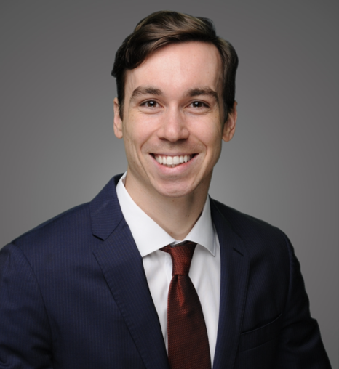

# Review of Operations

As of February 29, 2020, the Michael Price Student Investment Fund is divided into four autonomous sub funds, having dissolved the Small Cap Fund in March 2018: the Fixed Income Fund, the Growth Fund, the Value Fund, and the ESG Fund. Fund managers employ a well-defined, disciplined investment and diversification strategy.

We continued to work towards achieving the goals set by preceding Executive Committees while continuously striving to set new and better goals for the current year. Our progress and strategic objectives for the fiscal year were as follows:

* Improve the analytics and reporting process to drive greater insight and to focus energy on finding value across The Funds
* Continue development of the ESG Fund
* Provide focused sector and economic analysis to help make timely actionable investment recommendations
* Continue to invite successful investors as guest speakers to stimulate the learning process
* Hold Exchange Traded Funds (ETFs) over cash, whilst seeking attractive stocks to put money to work
* Improve the risk management process and employ quality screens and discussion of risks during each pitch

We started the semester with a “Pitching 101” session in which experienced second semester analysts presented best-in-class examples of stock pitches to the full class. Daniel Mendelsohn, Frank Zheng and Peter Lachman volunteered to present.

In addition to the practical rigor of stock selection, it was deemed important for the class to understand the procedural elements required to run a successful fund. Early in the semester, each analyst selected an administrative role, such as fund analytics or trade execution, to further the objectives of a holistic education.

Throughout the semester, the regular routine of stock pitches was interspersed with economic sector updates and guest speakers. Detailed economic analysis was presented by Jiyoung Choi, Raca Banerjee, Chain Vayakmonvichit, Eddie Stansky, Chen Ling, and Yipeng Dong, guiding many of the decisions made in the sub-funds.

We were delighted to welcome a number of notable speakers, including Mitch Williams, Michael Weinberg, Richard Saperstein, Randy Haase, Jared Mann, and Rob Browm. We are grateful to all these distinguished practitioners for giving up their time to provide deep and candid insight into the asset management industry.

**AUM & Cumulative Distributions**

The Funds began operating on March 1, 2000 with an endowment of $1.8 million. As of February 29, 2019, our assets under management stand at $2.1 million, which represents a cumulative return of 187.24% (net). On an annualized basis since inception, MPSIF has earned 5.37% net of brokerage commissions and fees, just above our required annual 5% distribution.

Jacques Cai

Annual Report Lead

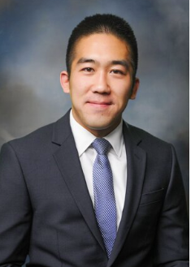

# Michael Price Student Investment Fund Performance

## Summary

## 

## Benchmark Index Description

The purpose of benchmarking is to track the Funds’ performance relative to the index that most closely resembles the investment mandate of each portfolio. It is important to note that while the Funds are measured against the market, our more critical and overarching goal is to provide an absolute rate of return that exceeds our annual distribution mandate to the University of Oklahoma plus the rate of inflation in a given year. Therefore, although we consider the aforementioned indices our benchmark, we are keenly focused on risk management in the construction of each sub-fund.

Each of the four sub funds—Fixed Income, Growth, Value, and ESG—are benchmarked to a leading index in order to measure relative performance. The benchmarks are as follows:

* Fixed Income: Vanguard Total Bond Index Fund
* Growth: Russell 1000 Growth Index
* Value: Russell 1000 Value Index
* ESG: S&P 500 Index

Vanguard Total Bond Index Fund measures the

performance of fixed income securities.

The benchmark has the following characteristics:

* Invests in U.S. Treasury, Investment-grade corporate, mortgage-backed, asset-backed securities
* Seeks to track the performance of the Barclays Capital Aggregate Bond Index
* Broadly diversifies exposure to investment-grade U.S. bond market
* Passively manages using index sampling
* Intermediate-duration portfolio and
* Provides moderate current income with high credit quality

The Russell 1000® Growth Index measures the performance of those Russell 1000 companies with higher price-to-book ratios and higher forecasted growth values.

The Russell 1000® Value Index measures the performance of those Russell 1000 companies with lower price-to-book ratios and lower forecasted growth values.

The S&P 500 Index measures the performance of the 500 largest U.S. publicly traded companies and serves as the benchmark for our new ESG Fund.

## Asset Allocation

The following chart shows our total asset allocation by asset class and our composite equity sector allocation. The Executive Committee does not utilize any top-down approach to set a target allocation.

During the last 6 months, overall the fund increased equity and fixed income holdings and decreased cash holdings.

Fixed income increased from 15.11% in the prior reporting period to 15.41%. Equities increased from 74.54% to 79.93% while cash decreased from 10.32% to 4.66%. These developments were largely attributable to further deployment of cash across the four sub-funds.

# The Growth Fund

## Message from the Portfolio Managers

## General Fund Discussion

For the six-month period from September 1st, 2019 to February 29th, 2020, the Growth Fund returned 4.88% versus the Russell 1000 Growth’s 5.41% - the fund’s relative performance was -54bps. Our fund peaked above $800,000 after the longest bull market in history in the first half of February, immediately followed by a spectacular market crash in the latter part of the month and March resulting from the spread of the novel coronavirus (“COVID-19”) pandemic and the escalation of lock-down measures globally. Our portfolio dropped below $600,000 in early March, wiping out a decade-worth of returns in under three weeks. As of 1st May prior to our annual distribution which amounted to $31,500, we had in excess of $726,500.

**Sector Allocation**

The Growth Fund is a bottom-up, long-term approach stock selection fund, but following on from the policy implemented by the previous team, we have kept our sector exposure in-line with the benchmark by using ETFs in sectors we have limited expertise to analyze individual companies. Unfortunately, with disappointing results given the underperformance of sector-specific ETFs versus our benchmark (such as Energy and Materials). We are gradually shifting from sector ETFs to specific names and while we do not assign analysts to cover any specific sector but rather allow them to specialize in sectors identified with their expertise, we have actively requested pitches in those sectors to which we had lower direct exposure. Analysts have pitched to reallocate the **iShares Global Consumer Discretionary ETF RXI** to direct positions in **HD** (home improvement retailer), **BURL** (off-price department store retailer), **BYND** (producer of plant-based meat substitutes) or **PLTN** (exercise equipment and media technology). We have completed the transition in Consumer Discretionary and are currently analyzing the Materials and Energy industries to find value in these beaten-up sectors before the summer break.

**Active vs Passive Portfolio**

We have witnessed a significant divergence in performance between our ETFs and our Active portfolio. Our Active portfolio has returned 6.66%, +125bps above the benchmark in the same period, whereas the ETF portfolio has returned -5.83%. This has been driven both by a severe underperformance of the **Global iShares Energy ETF IXC** (returned -21.09%) as well as the general underperformance of ETFs as the flight to quality driven by COVID-19 has penalized the worst-performers and indices representing a basket of mixed quality have suffered significantly. To find a silver lining in this otherwise disappointing news, we believe this is proof that alpha generation through active management is very real, particularly in times of severe disruption where the dislocation of capital leads to attractive entry points for solid stocks.

Adjustments to Working Remotely

The 10th of March was our final day of class before the University shut down for the remainder of the semester. A swift transition to working remotely has been key to running the class successfully. We left for Spring break with a Zoom session to coordinate stock updates which was followed by an email chain during Spring break over which all the analysts provided updated guidance to their stocks under a stress-test scenario of 25-50% drop in revenues for 2020 and a detailed analysis of liquidity positions for the stocks (with particular focus on debt covenant breaches that could lead to cross-default). A bottoms-up analysis by each analyst together with the stress-test scenario to provide us with a potential floor, were fundamental in rebalancing our portfolio and providing a specific strategy recommendation for each stock. We have connected for class as usual every week with impeccable attendance to discuss new (**BYND, PLTN**) and updated pitches (**UNH, FISV, GOOG/GOOGL, FB, MSFT** and **NKE**) as well as connect with the MAC members who have generously offered up their time and advice over Zoom. We continue to use email between sessions to facilitate communication and prepare the agenda of discussion points for each fund session.

**Stock Selection & Portfolio Construction**

Growth was the strongest performer on both an absolute and relative basis from September to February. We continued to maintain our discipline in investing the bulk of the portfolio in undervalued high-quality growth names and selling or trimming those we felt were over or fully valued.  We have balanced the blue-chip growth names with smaller exposures to some earlier stage or riskier growth companies that we believe have strong competitive positions and cash generation potential and offer attractive risk-adjusted returns.

Blue chip growth names with resilient business models and strong balance sheets have outperformed the broader market in the downturn and we continue to hold positions in those companies we believe are best positioned to weather the uncertainty ahead (**MSFT, AAPL,** **UNH** and **GOOG/GOOGL).** We implemented an ongoing monitoring process to trim fully-priced stocks such as **NVDA** and **PYPL**. This has allowed us to free up capital for new opportunities while maintaining exposure to resilient blue-chip growth stocks. We closed several positions through the semester in which we no longer saw favorable risk-adjusted returns. These included **VRSK** (high exposure to energy sector and oil majors) and **LYV** (short-term liquidity constraints driven by cancellation of live events for Q2 & Q3).

We also adjusted our voting process to improve our portfolio construction, considering the stock’s sector weight in the benchmark as well as our conviction on the upside to determine the size of our position. High-conviction allowed us to buy into the dip on our favorite names **MTCH, APPL, MSFT** and **FISV**. We were late however to cut our exposure to the airline industry through **TDG** (manufacturing of commercial and military aerospace components) and **CAE** (training and software for airlines and aircrafts) but have high conviction in the long-term resilience and quality of both these names which we believe will be best-positioned to recover given their leadership in the subsegments of aerospace in which they operate.

We have actively sought to leverage the experience of our MAC members in assisting us in our fiduciary duty to protect and grow the capital provided to the University by Michael Price. The advice and guidance provided by the board during these highly-volatile times has been invaluable in providing us with the framework to be able to analyze quickly and act with confidence in managing our fund. Special thank you to **Mitch, Richard, Randy, Mike, Jared** and **Rob (**and, of course, **Tony)** for their invaluable guidance through this semester.

**Administrative**

We define growth stocks to be the stock of companies with at least 5% revenue CAGR for the next three years. We have implemented detailed minutes to memorialize the class discussion and critical thinking coming from the group which we feel is the most valuable input to reach a decision. We believe it will be useful for future cohorts as they inherit positions or look at stocks that have been covered in the past. Finally, we implemented a confidence-weighted voting with a view to allow for various levels of conviction based on expertise in a particular stock or sector. It is still early to see if it results in improved decisions and returns.

This semester has provided us with a unique, once-in-a-lifetime learning opportunity and we firmly believe we have come out of the other side being better investors. We are grateful for the opportunity and humbled by the confidence bestowed upon us to manage capital with unparalleled independence, always supported and guidance of our MAC and faculty advisor.

Beatriz del Rio and Riaz Islam Co-Portfolio Managers, MPSIF Growth Fund

***Discussion of Performance***

*For the period ending February 29th, 2020:*



**Performance Overview**

The Growth Fund (“the Fund”) underperformed on a relative basis from September 1st, 2019 through February 29th, 2020. During that time period, the Fund’s six-month return was 4.88%, while the Russell 1000 Growth Index’s return was 5.41%. This represents a -0.54% relative return for the Fund.

**Stock Picking**

|  |  |
| --- | --- |
|  |  |
| **Top Performers** | **Return** |
| *Apple* | *63.34%* |
| *NVIDIA* | *61.23%* |
| *Align Technologies* | *47.64%* |
|  |  |
| **Bottom Performers** | **Return** |
| *Match.com* | *-21.66%* |
| *Discover Financial Services* | *-17.99%* |
| *Edwards Life Sciences* | *-16.42%* |
|  |  |
| ***Return:*** *measures the stock's return (excluding dividends) since the later of September 1st, 2019 or the date of acquisition to the earlier of February 29th, 2020 or the date of disposition.* | |
|
|
|
|
| ***Note:*** *in addition, this report uses prices as of the market close and not intraday numbers.* | |

The Growth Fund’s six-month return (from September 1st, 2019 to February 29th, 2019) of 4.88% underperformed the Russell 1000 Growth benchmark’s return of 5.41% over the same period. The Growth Fund currently holds 24 individual stocks. During the six-month period ending February 29th, 2020, 12 of those stocks generated positive returns.

**Top Performers**

**Apple:** we have held the stock since December 2015 increasing our position in March 2017. We trimmed our position partially in November 2019 resulting in a blended IRR 23.6% / 2.2x MOC. At reporting, the remaining stake traded at an implied 21.6% IRR / 1.5x MOC. We believe Apple controls the highest-value segments of the distribution value chain with a seamless hardware, operating system and payments solution. We continue to see upside as it transitions from a pure product play to a services offering and have chosen to increase our position post-COVID-19 (as of 30th April, our stake traded at implied IRR 23.5% / 1.3x MOC).

**NVIDIA:** graphics card chipmanufacturer for gaming, data centers and potential high-growth markets like autonomous vehicles. Positive secular trends, namely ubiquity of AI requiring high processing capacity and shift to cloud computing driving increase in data centers has driven growth for the stock. Originally purchase in November 2018, at reporting date our position traded at an implied IRR 24.5% / 1.3x MOC. We trimmed our position after a strong post-COVID-19 rally locking in an IRR 28.9% / 1.4x MOC on 80% of our cost basis. Our remaining stake traded at implied IRR 28.2% / 1.4x MOC as of 30th April.

**Align Technologies:** global medical device company best known for Invisalign orthodontic technology. Purchased in April 2018, the stock had traded up 50% during the summer months (past the analyst’s original target price) to then tank at the beginning of the school year and consistently underperform thereafter. We finally saw a recovery to the cost basis during the semester and given the lack of industry expertise in the fund chose to close the position to reallocate risk to names we felt more comfortable with, locking in IRR -0% / 0.0x MOC. Given the nature of the fund, we continue to how best to manage cases where a stock reaches target price during the summer months.

**Bottom Performers**

**Match.com:** is the leading provider of digital dating products (OkCupid, Tinder, Meetic, Hinge and +40 others). Strong YOY subscriber growth at 14% CAGR maintaining ARPU with 85% user retention are representative of a high-quality subscription business. As of reporting date, MTCH was trading at an implied IRR -76.8% / 0.8x MOC and our top underperformer. Looking forward it has proven to be one of the great success stories for our fund. We first purchased shares at $88 in December 2019. Given our high conviction in the name, with >70% upside at the trough, we increased our position in March 2019 to 8% from under 2% bringing the blended cost to $69. The stock has experienced a strong and fast rebound since and we have trimmed the position to rebalance our portfolio locking in a blended IRR 55.3% / 1.1x MOC. The remaining stake trades at $77 at an implied blended IRR 97.1% / 1.1x MOC.

**Discover Financial Services:** is a credit card operator and lender. Concerns about an increasing net charge-off rate in January (pointing to potentially higher default rates) and a 2x increase in loan loss reserves following the declaration of COVID-19 pandemic. Paired with a low interest environment for the foreseeable future, it has been significantly penalized by the market. Management has historically delivered strong loan growth while maintaining responsible lending and we remain confident in the potential for the stock through this crisis. Originally purchased in November 2013, as of reporting traded at an implied IRR 3.9% / 1.3x MOC.

**Edwards Life Sciences:** medical technology company focused on cardiovascular diseases. As of reporting, traded at an implied IRR -49.4% / 0.8x MOC. We believe it presents significant upside in a stable industry (cardiovascular disease is the number one cause of death in the world and we do not see this declining). EW has a market leading position in its TAVR device, which allows for minimally invasive heart valve replacements performed through a catheter rather than through an open- heart surgical procedure. They are pouring significant money into R&D and have promising devices in their pipeline. We believe it could also benefit from pent-up demand that will recover quickly as medical centers open-up when COVID-19 lock-down measures are relaxed. Stock has recovered slightly trading at implied IRR -24.2% / 0.9x MOC as of 30th April.

## Asset Allocation

At its core, the Growth Fund focuses on bottom-up stock-picking and fundamental analysis. The continued commitment to bottom-up stock selection is derived from the overall purpose of the course. The Fund is a seminar-style course in which students deploy skills learned in other classes in a hands-on and dynamic environment. We believe there are enormous benefits that come from the design of this course.

With that said, asset allocation is a significant focus and the Fund carefully considers appropriate allocation strategies. The Fund continues to utilize ETFs to increase its exposure to sectors with fewer individual security holdings, and we closely examine all of our holdings from a sector-specific context. This is done to ensure that the portfolio does not become drastically overweight in a particular sector for too long of a time period.

Despite our commitment to appropriate sector allocation, the Fund did differ from its benchmark at the end of the fiscal year. As of February 29th, 2020, the sectors with the most significant weight are:

* **Health Care**, which represents 11.5% of the Fund’s portfolio, is underweight relative to the benchmark (15.4%). United Health Care (UNH) and Edwards Lifesciences (EW) are our largest health care holdings.
* **Industrials**, which represents 11.3% of the Fund’s portfolio, is overweight relative to the benchmark (7.6%). Transdigm (TDG) and CAE (CAE) are the two largest holdings in the sector.
* **Financials,** which represents 5.4% of the Fund’s portfolio, is overweight relative to the benchmark (2.8%). Discover Financial Services (DFS) and The Hanover Group (THG) are our two major holdings in the sector.

To keep our sector exposure roughly in line with the Russell 1000 Growth Index, the Fund holds positions in iShares S&P Global Energy (IXC), iShares S&P Global Materials (MXI), iShares US Real Estate (IYR), Vanguard Consumer Staples (VDC), and iShares S&P Global Consumer Discretionary (RXI). We are gradually shifting from sector ETFs to specific names employing a bottom-up process which enables us to select best of breed stocks in each specific industry.

## Sector Allocation – Growth

## Holdings Profile

Growth Portfolio Holdings as of February 29th, 2020:



# *Investment Style and Strategy*

**Our goals:** The goal of the Growth Fund is to identify and capitalize on investments that have significant growth potential. The companies we invest in may derive their growth from a unique business model or a strong, competitive position in a rapidly growing industry. We require that revenue CAGR for the next 3 years is at least 5%. These growth opportunities can be uncovered by identifying companies that are pioneering a new product or service that will see significant future demand. Other growth companies may be disrupting pre-established norms in a mature industry and subsequently gaining significant market share. Additionally, these companies may be applying their business models to new regions or simply be an incumbent in an industry that is experiencing high levels of growth. Our analysts utilize intrinsic and comparable valuation techniques to determine if these growth companies are available at attractive prices.

**Our objective:** The core objective of the Fund is to outperform the benchmark on a total return basis by investing in securities that provide superior returns on a risk/return basis through capital appreciation and dividends.

**Investment process:** Our analysts look at a firm and ask, “What is the catalyst for growth?” The analyst will then consider whether the company’s business model will succeed in a competitive environment. A valuation analysis follows, which includes an extensive examination of the company’s financials and overarching industry trends and assumptions. In addition, the analyst will conduct relative valuations by comparing the company to its peers. The analyst then writes a research report and pitches the stock to the class, who then engages in a discussion to challenge the investment theses presented. After this rigorous process, the class votes on whether or not to add the security to the portfolio.

**Sell Discipline:** Although we still have the ability to execute sell stop-loss orders, we moved away from these last year as we believe that market movements should not mandate us to sell a stock, but rather that this should be done if there is a material change to the investment thesis. Instead, we mandated that if either the stock priced reached the analyst target price or if it was down 10% from the purchase price or previous update price the analyst would provide a short update on whether there was a change to the investment thesis or if the stock was now fully valued, and would then make a decision on whether to sell or hold. We continue to believe that periods of uncertainty and heightened volatility such as those presented through COVID-19 may provide buying opportunities at attractive valuations rather than selling, and fundamental analysis is the best way to identify these opportunities. Some of the factors that would change our investment thesis are:

* The company growth rate deteriorates, or its performance otherwise disappoints
* The price of the security reaches or exceeds our price target, or otherwise appears relatively high to the analyst
* The company publishes negative earnings announcements that could affect the long-term outlook and overall industry attractiveness
* The company experiences unfavorable changes in management

**Why Growth Stocks?** Growth companies have above average earnings growth, which we believe will translate into above average price appreciation. Thus, we believe investing in growth companies that are not currently overpriced should lead to realization of potentially superior investment returns over the long term.

# The Value Fund

## Message from the Portfolio Managers

## General Fund Discussion

For the six month period from September 1st 2019 to February 29th 2020, the Value Fund returned -6.53% versus the Russell 1000 Value’s -1.69%, underperforming on a relative basis by 4.85%. The underperformance during this period erased the fund’s outperformance from the last reporting period, resulting in a relative underperformance for the last 12 months of 0.24%. While the performance for this reported period was below benchmark, we believe that our long-term focus as well as the structural changes that we have implemented will lead to strong performance in the future.

Throughout the semester, we have shifted our portfolio to align more closely to the advice that MAC members have provided during their guest lectures.  We have focused on diversifying our sector allocations, investing in industry leaders with strong fundamentals, and ensuring that our investments align closely to our value investing strategy. More recently, COVID-19 represents an unprecedented challenge to investing and we have adapted our processes to evaluate the impact of this unforeseen factor.

**Sector Allocation**

A focus of the fund this semester has been to eliminate our cash holding balance and to reposition the portfolio’s sector exposure to align more closely to the Russell 1000 Value index and reduce the fund’s idiosyncratic risk. Our approach has not been to close the fund off from considering stocks that would make the portfolio more overweight in a given sector, but to evaluate such a pitch with an additional hurdle of a higher return that would be needed to compensate the fund for the additional idiosyncratic risk.

In support of this goal to balance the portfolio’s sector allocations, we have divested positions in overweight sectors such as Darden Restaurants Inc. from Consumer Discretionary and added positions in underweight sectors such as NextEra Energy from Utilities. We have evaluated certain sectors as a group and maintain an intentional underweight position to reflect our negative outlook on the sectors. Specifically, we have a negative outlook on the Energy sector as we believe that long term issues relating to oversupply and weaker demand will persist.

In the post COVID-19 era we have adapted our thinking on sector allocation by considering what sectors are more exposed to the slowdown, and what sectors are more likely to rebound quickly and benefit from built-up demand.

**Improving Stock Selection**

COVID-19 has strengthened our conviction on targeting high quality names as we believe that these stocks will be better positioned to recover quickly after the epidemic.  We also continue to test that our portfolio is made up of true value investments by ensuring that our existing and newly recommended stocks are in a stable, mature phase.  For this reason, on February 27 we placed a sell order for Take-Two Interactive, a video game company likely still in its growth phase.  We also provide specific investment theses to explain why the stocks are being valued by the market below their intrinsic value and their catalysts for change.

In response to COVID-19 we have reevaluated our portfolio to identify potential market over or underreactions. For example, in what we perceive to have been a possible market overreaction, we are looking at adding Disney to our portfolio as although it faces intense short-term headwinds due to the closure of parks, Disney has a strong monopoly position and diversified revenue streams, making it well positioned to recover quickly at the conclusion of COVID-19.

Despite these challenging times, the COVID-19 crisis and its corresponding market volatility has significantly broadened our new investment and educational opportunities.  We believe that the fund’s conversations around specific stocks and their interactions with global markets have been particularly thoughtful this term and should benefit participating students and the fund performance going forward.

Sam Simpson-Dore and Helena Duffee  
Co-Portfolio Managers, MPSIF Value Fund

# *Discussion of Performance*

*For the period ending February 29, 2020:*

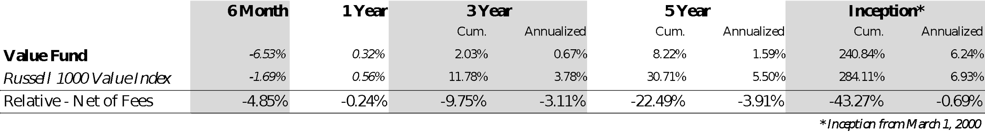

**Performance Overview**

The Value Fund underperformed on a relative basis from September 1st 2019 to February 29th 2020. During that time period, the Value Fund’s six-month return was -6.53%, while the Russell 1000 Value Index returned -1.69%. This represents a relative underperformance of 4.85%.

**Stock Picking**

|  |  |
| --- | --- |
|  |  |
| ***Top Performers*** | ***Return*** |
| *Microsoft* | *+17.52%* |
| *Philip Morris International* | *+13.57%* |
| *Gilead Sciences, Inc* | *+9.16%* |
|  |  |
| ***Bottom Performers*** | ***Return*** |
| *DuPont De Nemours Inc.* | *-36.85%* |
| *Deluxe Corporation* | *-33.48%* |
| *Tyson Foods* | *-21.10%* |
|  |  |
| ***Return:*** *measures the stock's return (excluding dividends) since the later of August 31, 2019 or the date of acquisition to the earlier of February 29, 2020 or the date of disposition.* | |
|
|
|
|
| ***Note:*** *in addition, this report uses prices as of the market close and not intraday numbers.* | |

The Value Fund’s six-month return (from August 31, 2019 through February 29, 2020) of -6.53% underperformed the Russell 1000 Value benchmark’s return of -1.69% over the same period. The Value Fund held 21 individual stocks over this time period. During the six-month period ending February 29 2020, seven of those stocks generated positive returns.

**Top Performers**

**Microsoft Corporation:** MSFT develops, manufactures, licenses, supports, and sells computer software, consumer electronics, personal computers, and related services. Growth has been driven by strong momentum in cloud services over the past year.

**Philip Morris International:** PM engages in manufacturing and sale of combustible and

e-cigarettes in over 180 markets. PM has performed well due to its high barriers to entry, high return on capital, geographic diversity, price-setting capability in many markets, and IQOS E-Cigarette launch provide compelling value.

**Gilead Sciences, Inc:** GILD is an American biopharmaceutical company that researches, develops and commercializes drugs. It focuses on treatment of HIV, hepatitis B, hepatitis C, and influenza. The company has seen slow but steady growth in the HIV market. Also, there has been increasing promise in the Immuno/Oncology sector.

**Bottom Performers**

**DuPont De Nemours Inc.:** DD was formed by merger of The Dow Chemical Company (DOW US) and DuPont (DD US) - 09/01/2017(DowDuPont) and subsequent spinoff of Dow and Corteva. The stock has traded down significantly post-spin (6/1/19), although the thesis is still in its early innings. DD is a hold as the tighter specialization of the new entity should allow for greater internal focus on key financial metrics to drive greater working capital and capital allocation efficiency.

**Deluxe Corporation:** DLX provides printed business forms, checks, marketing solutions, accessories, and other products and services for small businesses and financial institutions. The stock has traded down reflecting a recent announcement of lower than expected earnings, market concerns about the longevity of Deluxe’s core check printing business, and the feasibility of management’s pivot to technology services.

**Tyson Foods:** TSN is a leading protein processor (beef, chicken, and pork) and with growing exposure to more stable and higher growth packaged protein-based food. TSN is heavily U.S.-focused in its production. The stock fell ~18% in the month of February due to missing earnings, exports to China slowing due to Covid 19, and the broader market correction.

***Asset Allocation***

At its core, the Value Fund focuses on bottom-up stock-picking and fundamental analysis. The continued commitment to bottom-up stock selection is derived from the overall purpose of the course. The Fund is a seminar-style course in which students deploy skills learned in other classes in a hands-on and dynamic environment. We believe there are enormous benefits that come from the design of this course.

With that said, asset allocation is a significant focus and the Value Fund carefully considers appropriate allocation strategies. The Fund has the ability to utilize ETFs to gain exposure to certain industries which require specialized expertise, such as banking and biotechnology, in lieu of purchasing individual securities. Throughout this 6-month period it has been a goal of ours to focus on analyzing and pitching stocks in industry segments that our portfolio is underweight in.

Despite our commitment to appropriate sector allocation, the Fund did differ from its benchmark at the end of the fiscal year.

As of February 29, 2020, the sectors with the most significant weight in the Value Fund are:

* Industrials, which represents 15.27% of the Fund’s portfolio, is overweight relative to the benchmark (+5.58%). Deluxe Corp (DLX) is our largest holding in the industrials sector.
* Communication Services, which represents 14.57% of the Fund’s portfolio, is overweight relative to the benchmark (+6.22%). Electronic Arts (EA) and Take Two Interactive (TTWO) represent our two largest holdings in the sector.
* Consumer Staples, which represents 13.32% of the Fund’s portfolio, is overweight relative to the benchmark (+3.89%). Tyson Foods Inc (TSN) and Philip Morris (PM) are our largest consumer staples holdings.

***Sector Allocation – Value***

## Holdings Profile

Value Portfolio Holdings February 29, 2020:

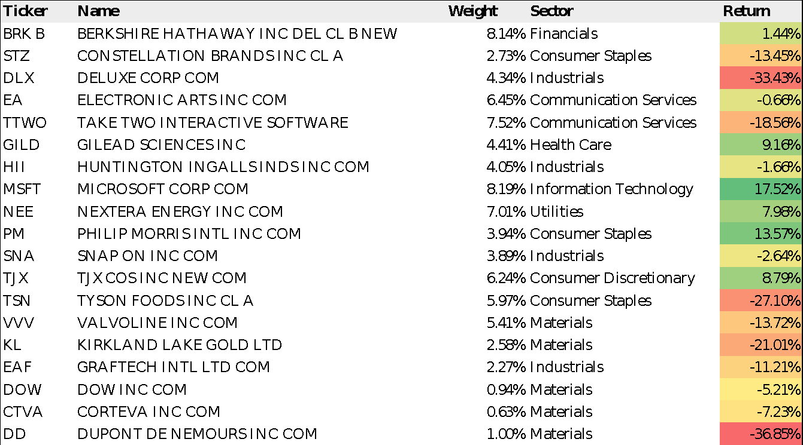

## Investment Style and Strategy

**Fund Objective:** Outperform the benchmark on a total return basis. Achieve superior returns by investing in securities which provide the best risk adjusted returns through capital appreciation and dividends.

**Benchmark:** Russell 1000 Value Index

**Fund Strategy:** The Value Fund utilizes a bottom-up approach to stock selection. Our analysts go through a rigorous screening process to select deep value positions. The team pursues this strategy by investing primarily in large capitalization companies with consistent year-over-year earnings that are trading at a discount relative to their peer group. We estimate the value of our securities primarily through an intrinsic value methodology. Additionally, we examine each security’s valuation relative to its peer group. For the purposes of this analysis, we utilize many of the following metrics: price-to-earnings, price-to-book, dividend yield, and various free-cash-flow ratios. There is, however, no specific country or region quota. Analysts discuss the Fund’s overall sector allocation compared to our benchmark to monitor our exposure, though we do not intentionally make sector bets. The Fund seeks absolute returns in order to fulfill our distribution requirements and monitors our performance against the Russell 1000 Value index.

**Why Value Stocks?** A value stock is one that is underpriced by the market for a wide variety of reasons. They are undervalued relative to their comparables on various metrics used to value comparable companies. Stocks that are undervalued on metrics compared to the index may not be Value stocks because sectors trade differently. Historical trading multiples are often a good indicator of whether a sector has a favorable perception.

**Cash:** The goal of the Fund is to be invested in the best value opportunities in the marketplace. Over the past few semesters, to the extent we have non-invested cash, we have invested in our benchmark ETF in an effort to minimize any cash drag. Our view remains conservatively positive in the next few months of this year. Therefore, we’re going to invest excess cash into benchmark ETF to ensure a balance sector allocation.

# The Fixed Income Fund

***Message from the Portfolio Managers***

**Economic Overview**

* The fixed income market was impacted by the world-wide shutdown due to the COVID-19 pandemic as well as the Saudi/Russian oil price war.
* Unemployment rate reaches 20%.
* U.S. 10-year Treasury hit all-time low at 0.52% in early March.
* U.S. oil prices turn negative for the first time in U.S. history.

The Federal Reserve took action by injecting the market with an estimate as high as $4 trillion to alleviate fears. Further, Congress approved a $2 trillion stimulus package which also bolstered the economy. The unemployment rate ranges at 20% with estimates forcesating 30% by June.

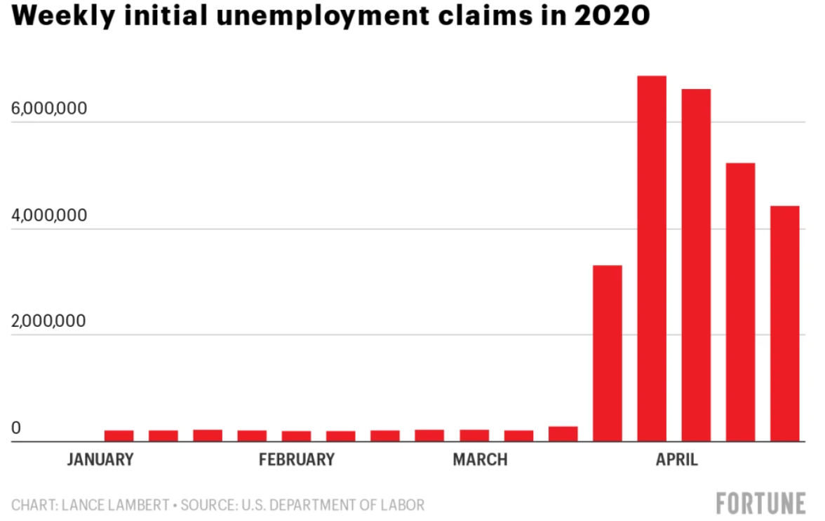

Since March, approximately 27 million people have filed for unemployment. All nonessential businesses have seen major cuts in their revenue streams. Restaurants are still offering take outs and delivery but with few willing to deliver the food, it becomes an even harder push to maintain their businesses. Another option is offering gift cards which show support and can help offset current costs. Travel and sports however has even fewer options. The Tokyo 2020 Olympics has been officially postponed until 2021. U.S. Treasury bond yields hit a low with the 10-year Treasury yield at 0.52% in early March.

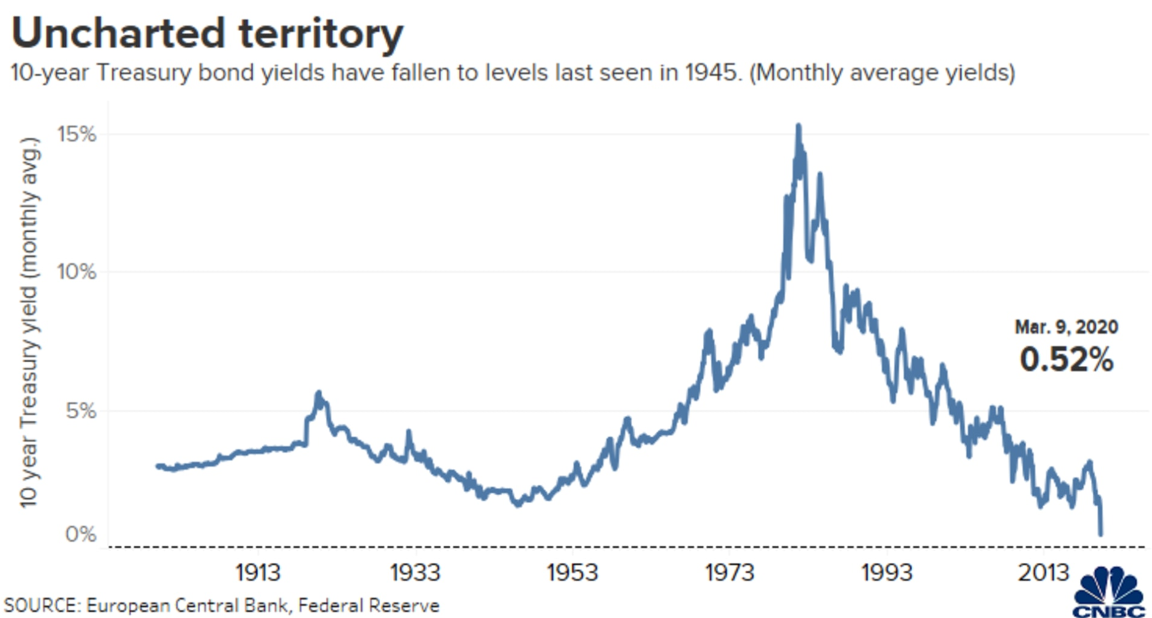

U.S. oil prices have turned negative for the first time in U.S. history with demand at an all-time low. This means oil producers have to pay buyers to take barrels off their hands with fears of storage capacity running out early Summer.

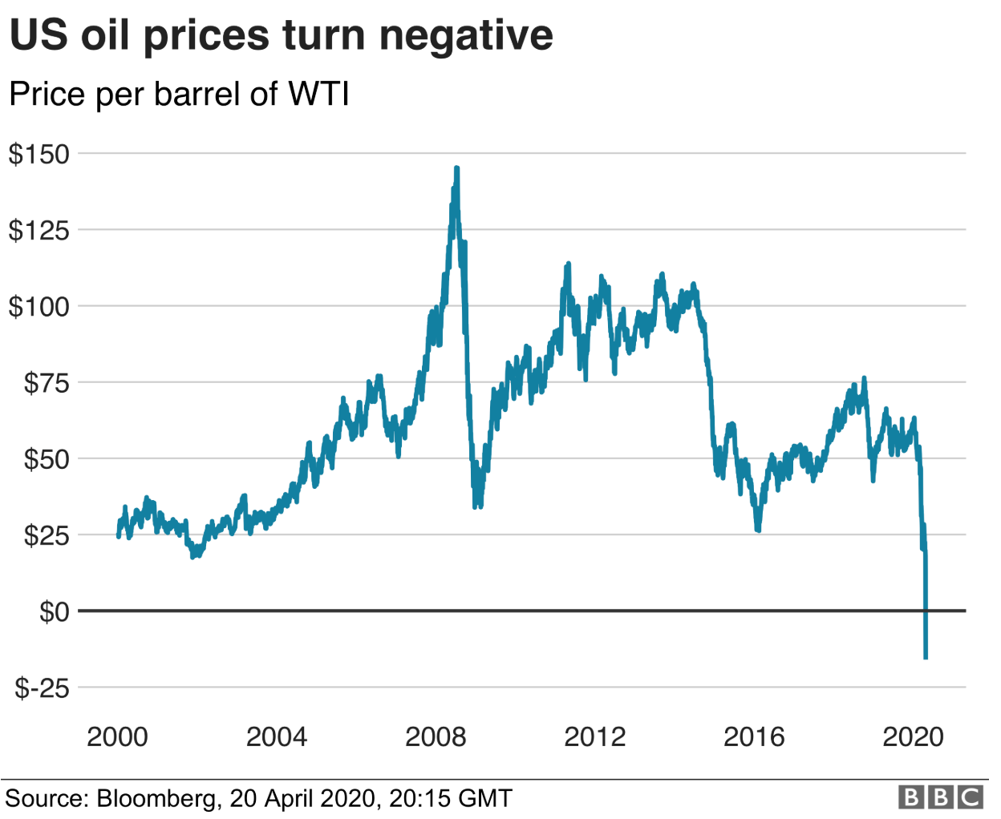

**Duration**The current duration of our portfolio is 5.54 years. Our benchmark duration is 6.20 years. Given the historically compressed level of US interest rates we don’t see a high duration strategy as an alpha generating one. Given the current economic environment and the Fed’s latest guidance we also believe the yield curve will stay at its levels for the foreseeable future.

Therefore, our strategy moving forward will be more related to picking specific fixed income instruments in sectors and geographies that we see as still having an attractive premium worth capturing.

Improving Our Portfolio

Currently we hold one mutual fund, PIMCO Inflation Response Multi- Asset Fund Class P. Given muted inflation data and a relatively high 1.55% net expense ratio, we would like to sell this fund.

**Increase Portfolio Diversification**

Our current portfolio holds 68.2% of the benchmark fund, the Vanguard total bond market ETF. Despite our tactical choice of maintaining an allocation closer to the benchmark due to high uncertainty levels, we would like to increase the size of the active positions in fixed income categories that we consider attractive, such as intermediate-term corporate bonds, and decrease our position in the benchmark fund. We target maintaining a 5% position size in each one of the active strategies.

Beatriz Abreu and Yelena Nemenko Co-Portfolio Managers, Fixed Income

***Discussion of Performance***

*For period ending February 28, 2019*

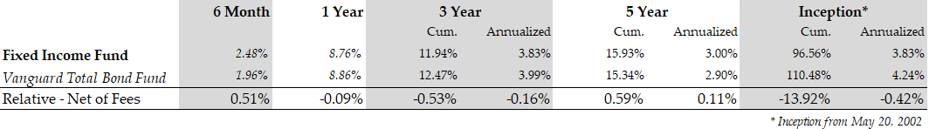

**Performance Overview**

Over the past 6 and 12 months, the Benchmark has earned 1.96% and 8.86% respectively. During the most recent 6-month, net of fees, the Fund outperformed the benchmark by 51 basis points.

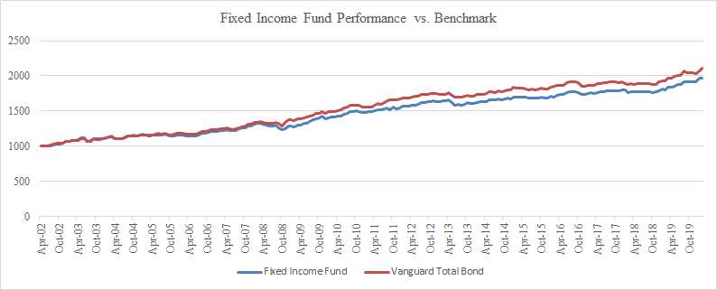

***Asset Allocation and Holdings Profile***

Each of the bond funds meets our goals as an investment vehicle for exposure to a particular sector. As of February 28, 2020, the largest positions were in the Vanguard Total Bond Market ETF (BND), iShares Treasury Core 1-5 Year USD Bond ETF (ISTB) and PIMCO Inflation Response Multi-Asset (PPRMX). As we go forward, we intend to continue to monitor these high-yielding instruments by looking for any updates on the underlying holdings. Our objective is to make investment decisions consistent with our view. In that regard, although the majority of our fund will be invested in quality high-grade treasuries and corporate bonds, as interest rates and yields stabilize – we would like to slightly increase our exposure to corporate bonds and lower our inflation-hedged assets. Throughout this process, we will also ensure that we increase the average duration of our portfolio so that it is better suited as the Fed is holding its rate hike process. Since the underlying assets and durations of our bond funds are subject to change, we will be closely monitoring and actively managing our investments.

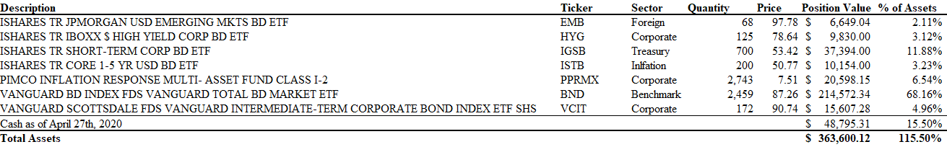

**Holdings by % (Excl. Cash)**

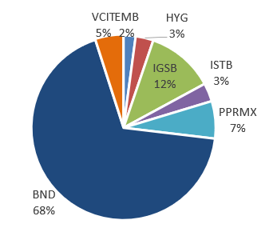

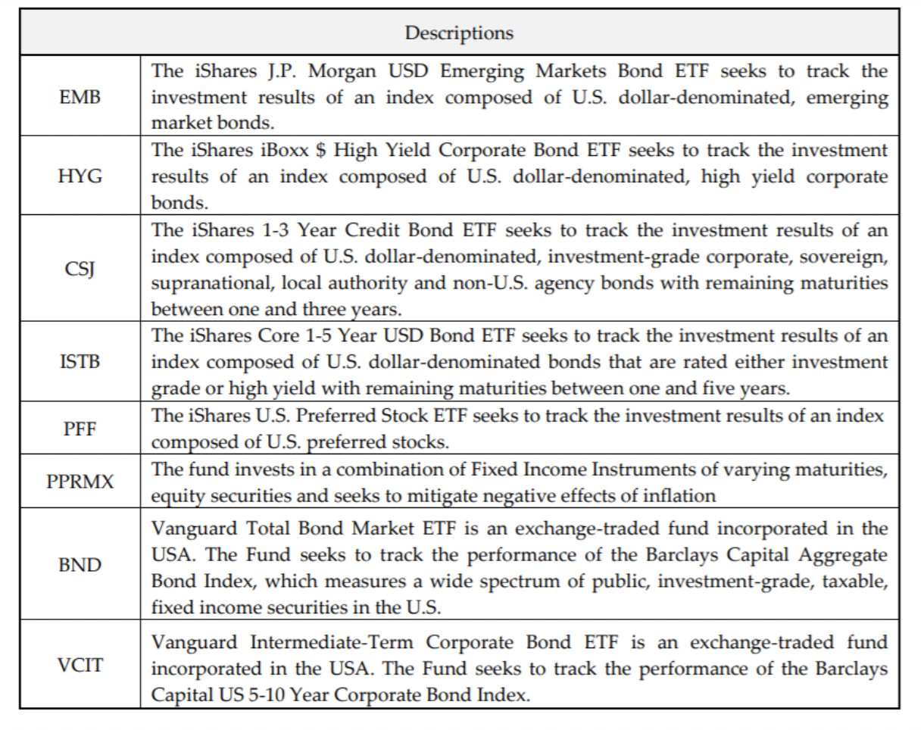

***Investment Style & Strategy***

The Fund seeks to outperform its benchmark, the Vanguard Total Bond Fund (VBMFX). The Fund implements its views through a top-down sector of the U.S. Fixed Income investment grade market, namely U.S. Treasuries, Corporate Bonds and Foreign Investment Grade Bonds (Emerging Markets and Developed Markets). Due to its tax-exempt status, the Fund does not invest in Municipal bonds. Also, the Fund does not engage in shorting, derivatives trading, or other non-linear investment strategies. Currently, the Fund does not buy individual securities due to the limited size of our trades and market spreads associated with buying individual securities. Instead the Fund invests in ETFs, mutual funds and other publicly traded funds to implement its sector allocation.

Due to the Fund’s inability to take positions in specific bond issues (limited dollar resources, the need to maintain a diversified fixed income portfolio and the limitations of our trading account), we use the Vanguard Total Bond Fund as our benchmark, as opposed to the more widely used Barclays Capital Aggregate Bond Index. Instead, we make sector allocation decisions and invest through ETFs and established mutual funds. We incur management fees, and thus benchmark to an index whose performance is also adversely impacted by mutual fund management fees. We felt it most appropriate to benchmark the fund to the bond mutual fund index with the least tracking error to the Barclays Capital Aggregate Bond Index, and thus chose the Vanguard Fund.

## The ESG Fund

## Message from the Portfolio Managers

**General Fund Discussion**

February 2019 saw the launch of the Environmental, Social and Governance (ESG) fund at NYU Stern as part of the Michael Price Student Investment Fund with a starting position of $350,000. For the six (6) month period from September 2019 to February 2020, the ESG Fund returned -1.71**%** versus 1.92% of the S&P 500. The fund’s relative performance was **-363bps.**

The letters "ESG" stand for environmental, social, and governance. We employ this strategy to examine criteria within these three categories to analyze stocks and combine the ESG lens with fundamental analysis. ESG factors cover a wide spectrum of issues that traditionally are not part of financial analysis, yet may have quantifiable financial relevance.

Throughout the fund operations, the ESG team had the opportunity to hear from and discuss with a number of speakers with experience investing across the ESG space. From these discussions, we got several takeaways regarding ESG and financial performance. Firstly, we can use ESG factors as a screening mechanism to improve stock selection by avoiding the worst performing ESG rated companies, protecting against downside risk and improving portfolio alpha.

Secondly, practitioners are quickly integrating ESG analysis into their fundamental analysis. As a result, valuation system should adapt accordingly to punish bad actors and reward good ESG actors.

Thus, having ESG analytics in fundamental research may generate alpha in the future as we price stocks more accurately with ESG considerations, even though there is no direct evidence of outperformance right now.

We are looking for undervalued stocks that are compelling and with sustainable earnings trajectory. Meanwhile, we value their risk profiles according to our ESG standard. While many ESG rated companies promote many ESG factors in corporate sustainability reports, we focused on the top ESG issues which were deemed to be “material” to a given company. Every pitch contained information of what ESG factors were “material” to that company and how the company fared with regard to those issues. We leveraged resources such as MSCI rankings, Sustainalytics, SASB and companies’ own reports to determine which ESG factors were material to a given company and how the company performed on those specific material ESG factors. We then use that as a component in the overall evaluation of the stock, including ESG factors alongside traditional valuation.

Dimitrios Niarchos and Jiang Li

Co-Portfolio Managers, MPSIF ESG Fund

**Stock Picking**

|  |  |
| --- | --- |
|  |  |
| ***Top Performers*** | ***Return*** |
| *Resmed* | *+14.11%* |
| *Salesforce* | *+7.61%* |
| *Autodesk* | *+7.21%* |
|  |  |
| ***Bottom Performers*** | ***Return*** |
| *Starbucks* | *-18.78%* |
| *Bank of America* | *-14.82%* |
| *Welltower* | *-11.45%* |
|  |  |
| ***Return:*** *measures the stock's return (excluding dividends) since the later of August 31, 2019 or the date of acquisition to the earlier of February 29, 2020 or the date of disposition.* | |
|
|
|
|
| ***Note:*** *This report uses prices as of the market close and not intraday numbers.* | |

**Top Performers**

**ResMed:** ResMed is engaged in the development, manufacturing, distribution and marketing of medical devices and cloud-based software applications that diagnose, treat and manage respiratory disorders, including sleep disordered breathing (SDB), chronic obstructive pulmonary disease (COPD), neuromuscular disease and other diseases. ResMed has a leading position in the sleep disorder equipment market. ResMed has been growing at low double digits for recent years due to market growth and continued product innovation. We believe the momentum will continue as awareness of sleep apnea grows and the company keeps their innovation in new markets and digital applications.

**Salesforce:** Salesforce is a cloud-based software provider based in San Francisco. It helps companies across the world better manage customer relationships and increase productivity with its CRM service and complementary suite of enterprise applications focused on customer service, marketing automation, analytics, and application development. Its stock has been driven up by continuous high revenue growth rate.

**Autodesk:** Autodesk provides a suite of specialty software for the architecture, engineering, construction, manufacturing, media, education, and entertainment industries. Its sustained organic growth plus successful execution of pivoting to a SaaS revenue model drove its stock sharply higher over the period before concerns about coronavirus pared down some gains at the end of February.

**Bottom Performers**

**Starbucks:** Starbucks is the world’s largest coffee chain with over 31,000 stores worldwide as of 2019. Its stock dropped at the beginning of the period due to weaker than expected 2020 earnings guidelines. Its stock dropped further in January and February due to store closures in China and expected store closures in Europe and North America due to the coronavirus.

**Bank of America:** Bank of America is one of the largest banks in the USA. It provides products and services to consumers, businesses and financial institutions. Its stock dropped sharply towards the end of the period due to expectation of negative economic impact from the coronavirus.

**Welltower**: Welltower is a Real Estate Investment Trust with assets primarily in healthcare related facilities, including senior housing, assisted living communities, post-acute care facilities, and medical office buildings, etc. Its stock dropped towards the end of the period due to expected shock to its revenue from the coronavirus.

## Holdings Profile

ESG Portfolio Holdings February 29, 2020:

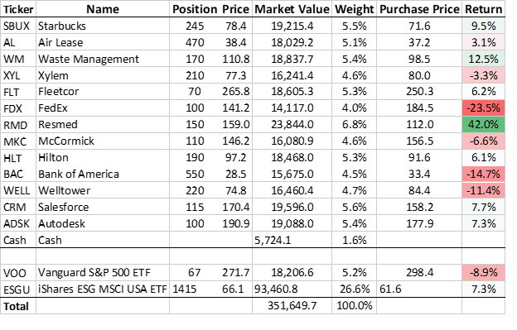

## Sector Allocation – ESG

The sector allocation below is a result of our bottom-up stock selection. Although we do tend to cover all sectors without too much tracking error compared to the benchmark, it would be difficult to achieve diversification with only 13 stocks. During the past year, we have tilted our stock selection to mitigate the tracking error by adding more exposure in under-allocated sectors.

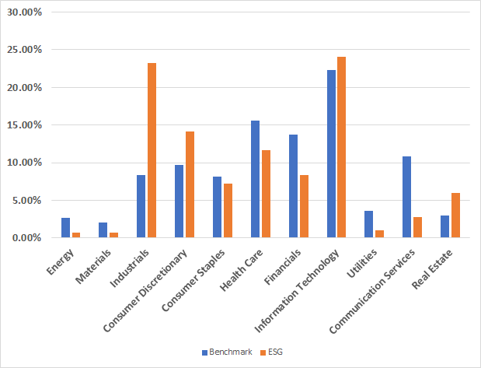

*ESG data as of February 2020, ETFs decomposed to calculate sector allocation

*Excludes cash position

*ETF data as of April 2020

***Investment Style & Strategy***

**Fund Objective:** Outperform the benchmark on a total return basis. Achieve superior returns by investing in securities that provide the best risk adjusted returns through capital appreciation and dividends.

**Benchmark:** S&P 500 Index

**Fund Strategy:** We integrate ESG factors into fundamental analysis to comprehensively evaluate stocks. The strategies deployed include avoid or reduce ESG risks, generate higher investment returns and seek measurable impact, among others.

**Why ESG Stocks?** As discussed in General Fund Discussion, we believe having ESG factors in traditional fundamental analysis will contribute alpha for the fund. Thinking about ESG is fundamentally important to all of our investment decisions and it is a theme that fits in with the value style of investing.

**Cash:** The goal of the Fund is to be invested in the best opportunities in the marketplace. Over the past few semesters, to the extent we have non-invested cash, we have invested in our benchmark ETF in an effort to minimize any cash drag. Our view remains conservatively positive in the next few months of this year. Therefore, we’re going to invest excess cash into a benchmark ETF to ensure a balance sector allocation.

**Improving Portfolio construction:** The goal of the ESG investment process is to generate excess returns. We will continue to focus on finding out undervalued and ESG qualified stocks. We favor companies with high ESG scores and may lean more heavily on certain industries and sectors than their non-ESG peers.

# The Executive Committee

**Professor Anthony Marciano - *Faculty Advisor***

Anthony Marciano is Clinical Professor of Finance at New York University Stern School of Business, where he teaches courses in Corporate and Behavioral Finance. Previously, he was on the faculty at the University of Chicago Booth School of Business where he won multiple teaching awards and was listed on the Business Week list of outstanding faculty. Tony also visited at the MIT Sloan School of Management and Northwestern's Kellogg School of Management, where he similarly was one of the highest rated instructors. Tony has also worked for Goldman Sachs in the financial institutions area after receiving his MBA from Sloan, which followed employment at Morgan Stanley and Drexel Burnham Lambert. He has a B.A. from Dartmouth College.

**Bryce Mendes - *President***

Bryce Mendes is a second-year MBA student at NYU Stern. He previously worked at PwC in their assurance practice, and is a Certificated Public Accountant. Bryce graduated from the University of North Carolina with a B.A. in Economics and Spanish, and received his master of accounting degree from UNC's Kenan-Flagler Business School.

**Beatriz del Rio - *Co-Portfolio Manager, Growth Fund***

Beatriz del Rio is a focused Technology MBA student specializing in Technology Operations, Entrepreneurship & Innovation. Prior to Stern, Beatriz worked as a venture capital investor at Seaya Ventures. Prior to that, she worked in the Infrastructure Private Equity division of GIC Singapore and the Mergers & Acquisitions division of Morgan Stanley. Beatriz graduated with a J.D. in Law and B.A. in Economics from ICADE Universidad Pontificia Comillas in Madrid, Spain.

**Riazul Islam - *Co-Portfolio Manager, Growth Fund***

Riazul Islam is a second-year MBA student specializing in Product Management and Business Analytics, and has a B.S. from NYU Stern. Prior to rejoining Stern, Riaz worked at Gartner as an internal strategy consultant and ZS Associates as a business analytics consultant. He spent the previous summer working as a Product Management intern at Verizon Smart Cities.

**Sam Simpson-Dore - *Co-Portfolio Manager, Value Fund***

Sam Simpson-Dore is a second-year MBA student. Prior to Stern, Sam worked as an Engineer and a Project Manager in the nuclear power industry. Sam holds an MSc in Mechanical Engineering from the University of Pennsylvania and a BEng in Mechanical Engineering from the University of Edinburgh. He spent the summer at Lazard in the Industrials group in New York and will be returning after graduation.

**Helena Duffee - *Co-Portfolio Manager, Value Fund***

Helena Duffee has a B.S. in Economics and English from Tulane University. Prior to Stern, she worked as a Financial Economist at Fannie Mae, primarily in support of their credit risk transfer programs. She spent the last summer as an Investment Banking Associate at Guggenheim Securities, where she will return full time.

**Beatriz Abreu – *Co-Portfolio Manager, Fixed Income Fund***

Beatriz Abreu, CFA is a first-year MBA student and holds a B.S. in Economics from University of Sao Paulo in Brazil. Prior to Stern, Beatriz worked as a fixed income portfolio manager at Bradesco, where she conducted active fixed income investment strategies, such as interest rate risk management, yield curve, and breakeven inflation related positions.

**Yelena Nemenko - *Co-Portfolio Manager, Fixed Income Fund***

Yelena Nemenko is a finance M.B.A. candidate at New York University’s Stern School of Business. She graduated with a B.B.A. from Pace University. She is currently Vice President at Atalanta Sosnoff and began as an Associate in 2010. She was formerly an Asset Servicing Analyst at BNY Mellon and began her career at Bank of New York in their Securities Lending division.

**Jiang Li - *Co-Portfolio Manager, ESG Fund***

Jiang Li is a second-year MBA with a focus on finance and strategy. Jiang graduated from Sun Yat-sen University in China with a B.S. in Theoretical and Applied Mechanics. Prior to Stern, he worked as a quantitative financial analyst for Cigna’s variable annuities business in CT and Hong Kong. Jiang passed all three levels of the CFA exams.

**Dimitrios Niarchos - *Co-Portfolio Manager, ESG Fund***

Dimitrios Niarchos is a second-year MBA student specializing in Accounting, Finance, and Financial Instruments and Markets. Prior to NYU Stern, Dimitrios worked as an engineer advising clients on the design and construction of large-scale infrastructure projects. Over the summer, he interned at State Street in Boston, where he will return after graduation as a Rotational Associate. Dimitrios holds a MSc in Civil Engineering from Massachusetts Institute of Technology and a BSc from National Technical University of Athens, Greece.

***The Growth Fund***

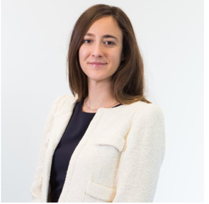

Beatriz del Rio is a focused Technology MBA specializing in Technology Operations, Entrepreneurship & Innovation. Prior to Stern, Beatriz worked as a venture capital investor at Seaya Ventures. Prior to that, she worked in the Infrastructure Private Equity division of GIC Singapore and the Mergers & Acquisitions division of Morgan Stanley. Beatriz graduated with a J.D. in Law and B.A. in Economics from ICADE Universidad Pontificia Comillas in Madrid, Spain.



**Riazul Islam** is a second-year MBA student specializing in Product Management and Business Analytics, and has a B.S. from NYU Stern. Prior to rejoining Stern, Riaz worked at Gartner as an internal strategy consultant and ZS Associates as a business analytics consultant. He spent the previous summer working as a Product Management intern at Verizon Smart Cities.

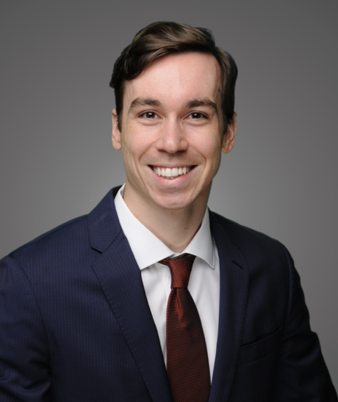

**Bryce Mendes** is a second-year MBA student at NYU Stern. He previously worked at PwC in their assurance practice and is a Certified Public Accountant. Bryce graduated from the University of North Carolina with a B.A. in Economics and Spanish and received his Master of Accounting degree from UNC's Kenan-Flagler Business School. He spent his summer as an Investment Banking Associate at Piper Jaffray, where he will be returning full-time upon graduation.

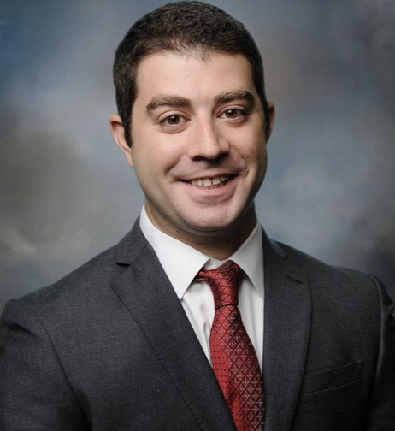

**Daniel Mendelsohn** is an MBA2 specializing in Corporate Finance, Accounting and FinTech. Prior to attending Stern, Daniel worked at Office Depot as a member of their Corporate Financial Planning & Analysis team. Most recently, Daniel interned as a Summer Investment Banking Associate at Goldman Sachs in the firm’s Financial Institutions Group, where he will be returning full-time upon graduation.



**Yelena Nemenko** is a finance M.B.A. candidate at New York University’s Stern School of Business. She graduated with a B.B.A. from Pace University. She is currently Vice President at Atalanta Sosnoff and began as an Associate in 2010. She was formerly an Asset Servicing Analyst at BNY Mellon and began her career at Bank of New York in their Securities Lending division.



**Hannah Rose Schonwald** is a second year MBA student specializing in Strategy and Finance. Prior to Stern, Hannah Rose was a scientist at the Center for Negative Carbon Emissions. She holds a B.A. in Geochemistry from Brown University and a M.S. in Sustainable Engineering from Arizona State University. Most recently Hannah Rose interned at Pfizer in Corporate Finance. After graduating, Hannah Rose will join The Brattle Group full-time.

**Chain Vayakornvichit** is a first-year MBA student specializing in Finance and Strategy and holds a B.A. from the University of Oxford in Philosophy, Politics and Economics. Prior to Stern, he worked in strategy consulting with Parthenon-EY for 2 years, helped grow Zilingo, a fashion marketplace, from seed stage to Series D and was a co-founding team member at Vouch, an insurance start-up.



**Eddie Stansky** is a first year MBA student and holds a B.S. in Economics with a finance concentration from Duke University. Prior to Stern, Eddie was an investment banking analyst at Bank of America Merrill Lynch and a research analyst at DDJ Capital.



**Jacques Cai** is a first-year MBA student specializing in Corporate Finance and Accounting. Prior to Stern, Jacques worked at Morgan Stanley as an Associate in their Treasury division. He holds a B.A. in Economics from New York University.

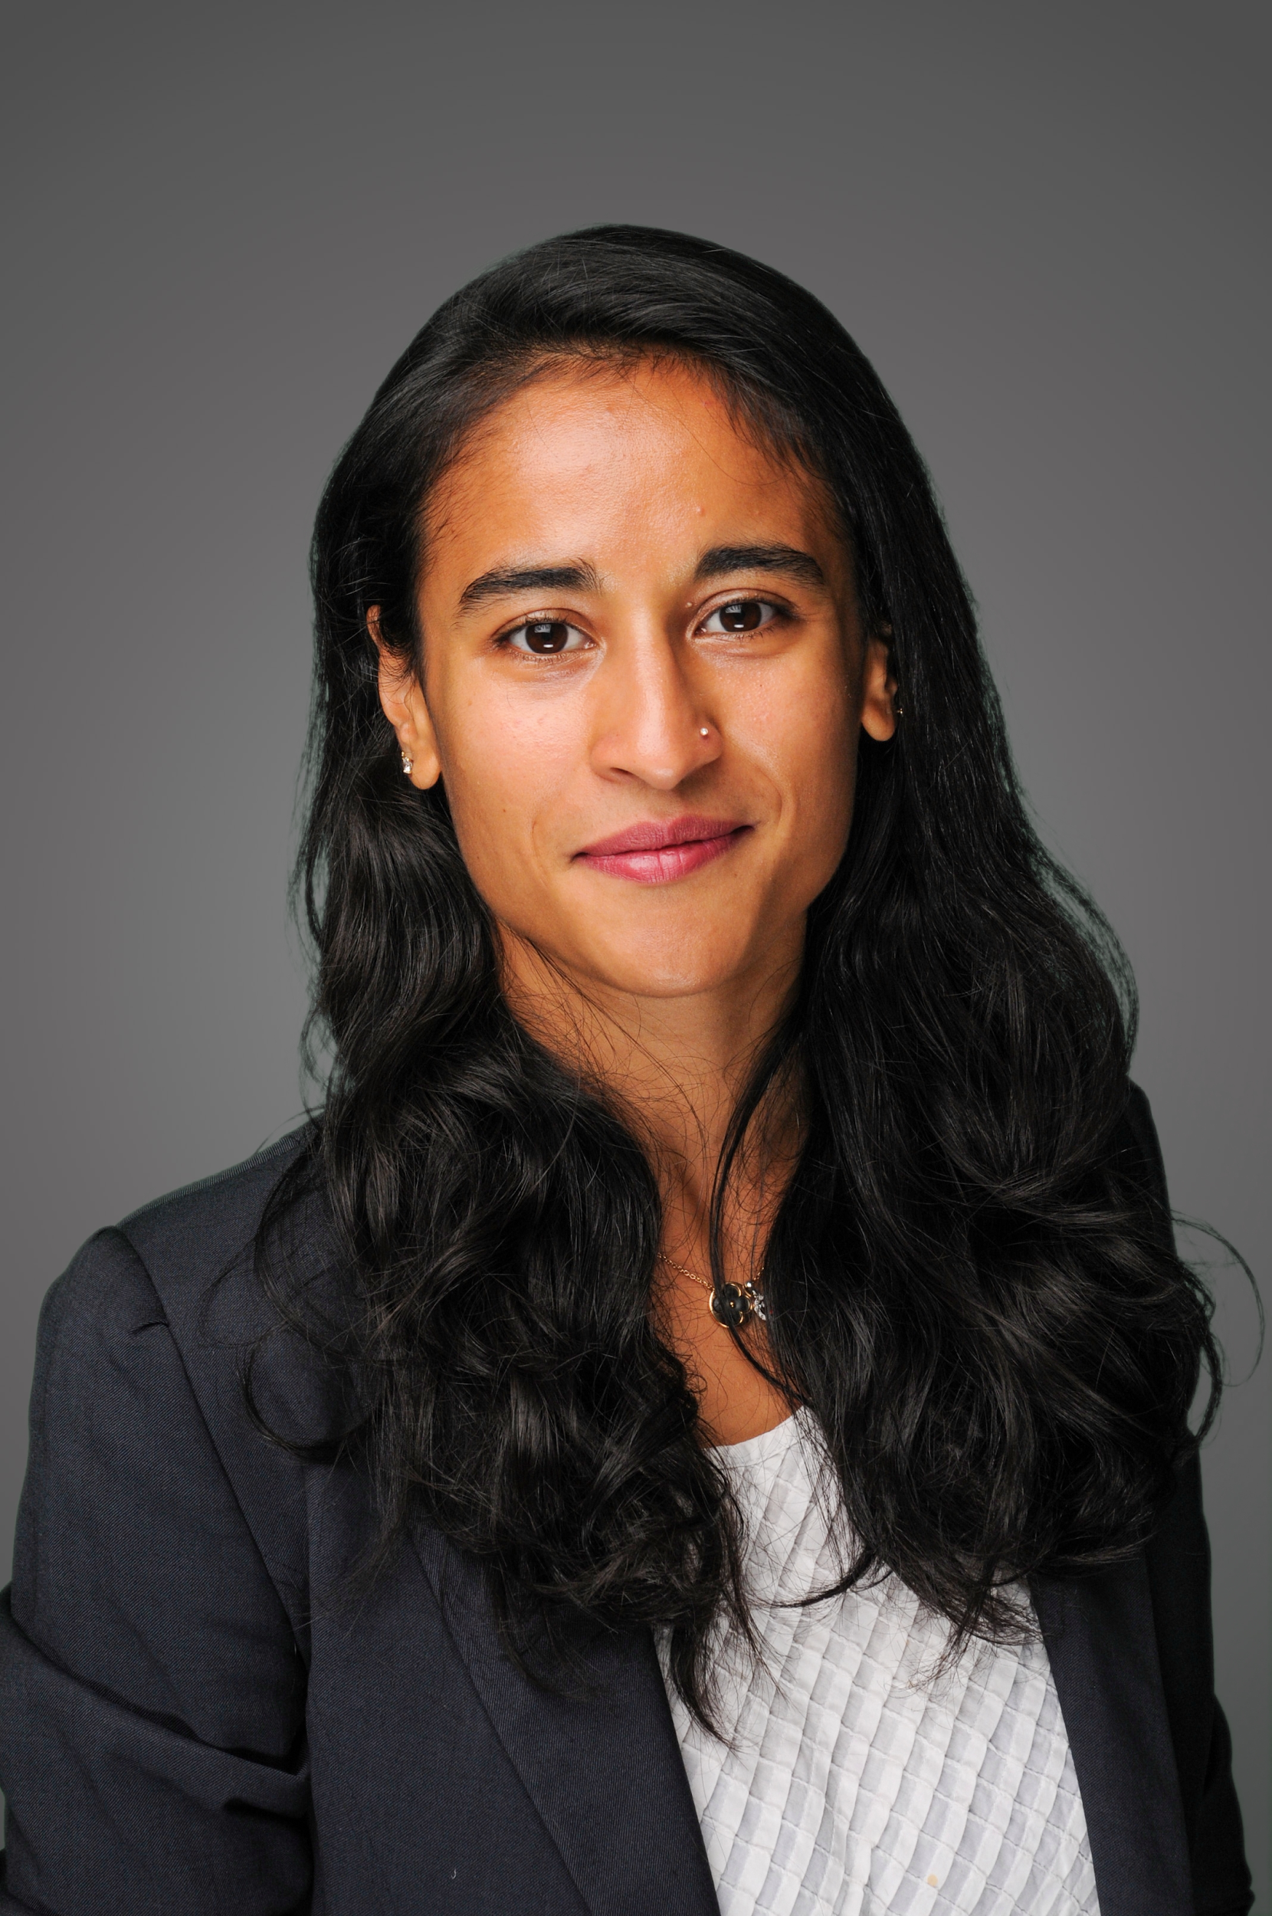

**Rukshan Mehra** is a first year MBA student specializing in Finance and Accounting. Rukshan has spent eight years working in Telecoms, Media and Technology (TMT) before coming to Stern, including six years as an Analyst and later as a Strategy Consultant, advising globally leading broadcast, media, cable and mobile operators. Rukshan holds an MA (Hons) Psychology and Business Studies from the University of Edinburgh, and has completed two levels of the CFA program.

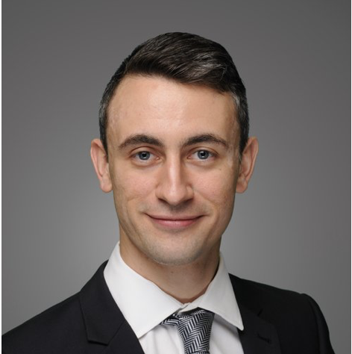***The Value Fund***

**Sam Simpson-Dore** is a second-year MBA student. Prior to Stern, Sam worked as an Engineer and a Project Manager in the nuclear power industry. Sam holds an MSc in Mechanical Engineering from the University of Pennsylvania and a BEng in Mechanical Engineering from the University of Edinburgh. He spent the summer at Lazard in the Industrials group in New York and will be returning after graduation.



**Helena Duffee** has a B.S. in Economics and English from Tulane University. Prior to Stern, she worked as a Financial Economist at Fannie Mae, primarily in support of their credit risk transfer programs. She spent the last summer as an Investment Banking Associate at Guggenheim Securities, where she will return full time.

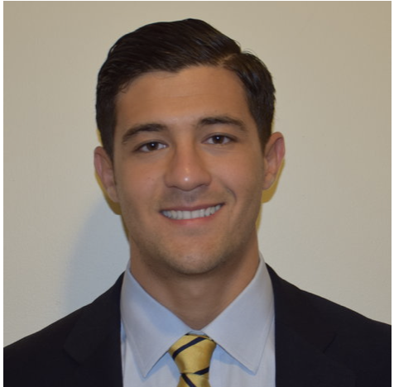

**Adam Kayali** is a second year MBA student specializing in Finance, Accounting and Strategy. Prior to Stern, Adam worked at GoldenTree Asset Management in the Operations group. He graduated from Baruch College with a B.B.A. in Finance and Investments. Adam spent his summer at Guggenheim Securities as an Associate in their generalist pool.



**Austin Ebenger** is a first-year MBA student and a Berkley Scholar. Prior to Stern, Austen spent time as a private equity investor at Altamont Capital Partners and in investment banking at Bank Street Group. Austen holds a BS in Economics with specializations in Finance, Accounting, and Management from The Wharton School at the University of Pennsylvania. Austen will spend this upcoming summer working in private equity at Great Hill Partners.



**Yipeng Dong** is a first-year MPA student from NYU Wagner specializing in Social Impact, Innovation, and Investment. She graduated from University of Delaware with a B.S. in Finance. Prior to NYU, she was an Investment Analyst at MiYin Investment Management in Hangzhou, China. She currently interns at 17 Asset Management.

**Chen Ling** is a first-year MBA student specializing in Finance and Business Analytics. Prior to Stern, Chen worked as an institutional trader at TD Ameritrade and as a financial planner at Stratos Wealth Partners. She holds a B.S. in Economics from University of California, San Diego.



**Raca Banerjee** is a second year MBA student graduating in May. Prior to Stern, Raca worked in healthcare market research providing in-depth policy and regulatory analysis to institutional investors, sell-side analysts, hedge funds, and private equity firms. She has also partnered with various entrepreneurs and venture capitalists in the health technology space to help bring innovative digital health products to market. Raca is a graduate of Cornell University.

**Peter Lachman**

**Jiyoung Choi**

## The ESG Fund

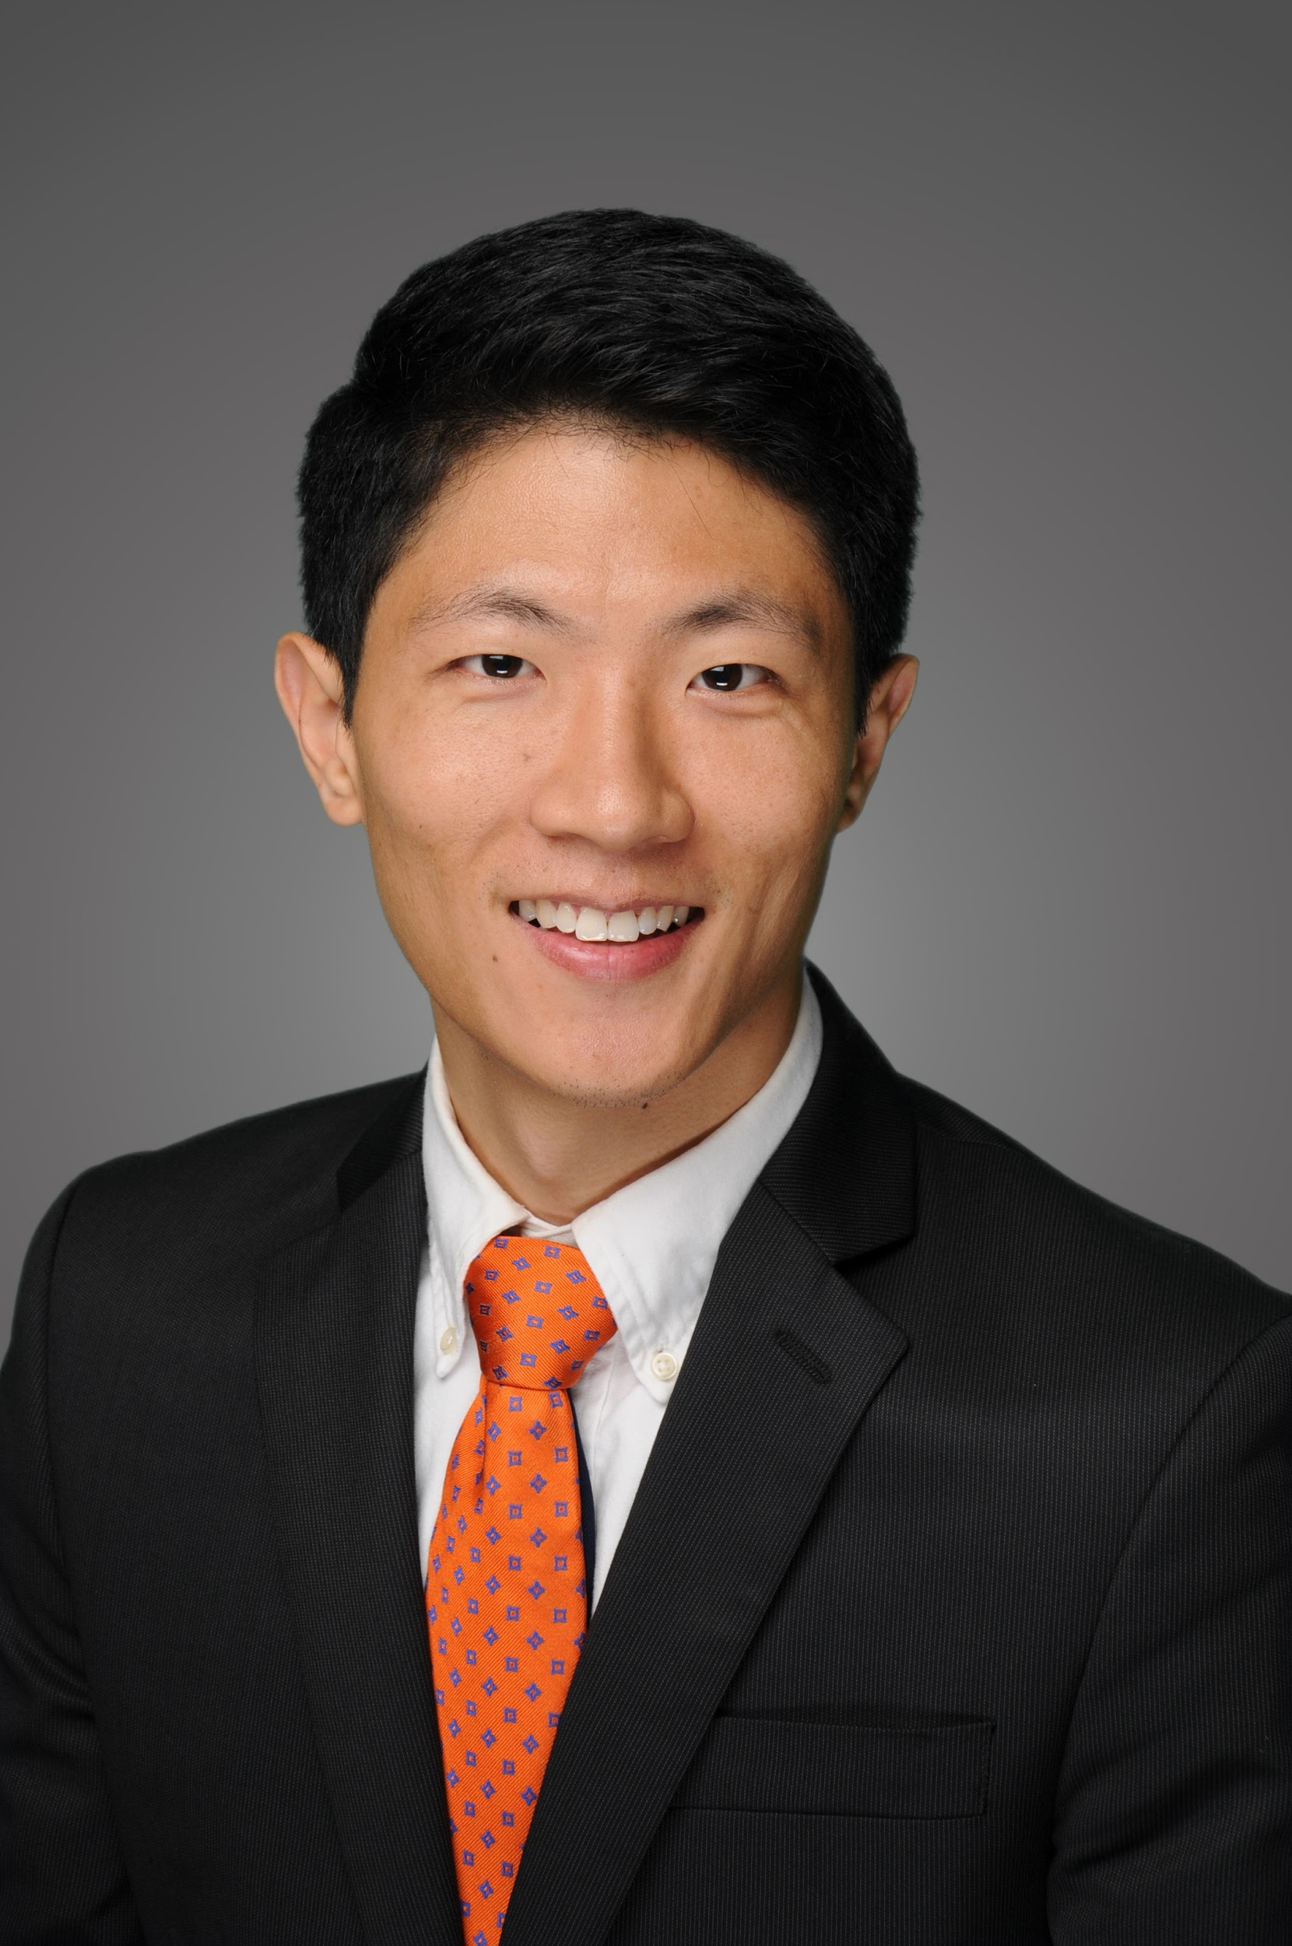**Jiang Li** is a second-year MBA with a focus on finance and strategy. Jiang graduated from Sun Yat-sen University in China with a B.S. in Theoretical and Applied Mechanics. Prior to Stern, he worked as a quantitative financial analyst for Cigna’s variable annuities business in CT and Hong Kong. Jiang passed all three levels of the CFA exams.



**Dimitrios Niarchos** is a second-year MBA student specializing in Accounting, Finance, and Financial Instruments and Markets. Prior to NYU Stern, Dimitrios worked as an engineer advising clients on the design and construction of large-scale infrastructure projects. Over the summer, he interned at State Street in Boston, where he will return after graduation as a Rotational Associate. Dimitrios holds a MSc in Civil Engineering from Massachusetts Institute of Technology and a BSc from National Technical University of Athens, Greece.

**Jonghwan Kim** is a first-year MBA student with a focus on finance, financial instruments and markets. He graduated with a degree in Business Administration and a minor in Law from Seoul National University in Korea. Prior to Stern, he worked at Korea Exchange for 7 years, where he facilitated the growth of the Exchange-traded Product industry and promoted Korean companies’ investor relations events in China, Hong Kong, and Singapore.

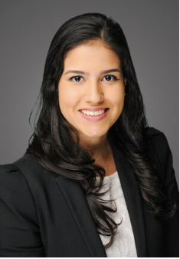

**Beatriz Abreu, CFA** is a first-year MBA student and holds a B.S. in Economics from University of Sao Paulo in Brazil. Prior to Stern, Beatriz worked as a fixed income portfolio manager at Bradesco, where she conducted active fixed income investment strategies, such as interest rate risk management, yield curve, and breakeven inflation related positions.



**Frank Zheng** is a first year MBA student. Prior to NYU Stern, Frank worked as a fixed income trader at Standard Chartered, covering rates bonds and derivatives. Frank graduated with a B.S. in Mathematics and Statistics from University of Michigan.

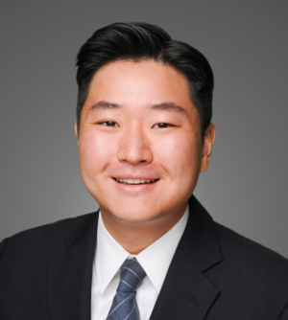

**Justin Lee** is a first-year MBA student. Prior to Stern, Justin worked as a Research Associate covering consumer discretionary stocks across Western Europe and Emerging Asia for a long-only fund. He holds a B.A. in Economics from Dartmouth College.

## The Fixed Income Fund

**Beatriz Abreu, CFA** is a first-year MBA student and holds a B.S. in Economics from University of Sao Paulo in Brazil. Prior to Stern, Beatriz worked as a fixed income portfolio manager at Bradesco, where she conducted active fixed income investment strategies, such as interest rate risk management, yield curve, and breakeven inflation related positions.



**Yelena Nemenko** is a finance M.B.A. candidate at New York University’s Stern School of Business. She graduated with a B.B.A. from Pace University. She is currently Vice President at Atalanta Sosnoff and began as an Associate in 2010. She was formerly an Asset Servicing Analyst at BNY Mellon and began her career at Bank of New York in their Securities Lending division.



**Chain Vayakornvichit** is a first-year MBA student specializing in Finance and Strategy and holds a B.A. from the University of Oxford in Philosophy, Politics and Economics. Prior to Stern, he worked in strategy consulting with Parthenon-EY for 2 years, helped grow Zilingo, a fashion marketplace, from seed stage to Series D and was a co-founding team member at Vouch, an insurance start-up.

**Yipeng Dong** is a first-year MPA student from NYU Wagner specializing in Social Impact, Innovation, and Investment. She graduated from University of Delaware with a B.S. in Finance. Prior to NYU, she was an Investment Analyst at MiYin Investment Management in Hangzhou, China. She currently interns at 17 Asset Management.



**Chen Ling** is a first-year MBA student specializing in Finance and Business Analytics. Prior to Stern, Chen worked as an institutional trader at TD Ameritrade and as a financial planner at Stratos Wealth Partners. She holds a B.S. in Economics from University of California, San Diego.

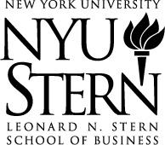

The Michael Price  
Student Investment Fund  
44 West Fourth Street  
New York, N.Y. 10012

http://pages.stern.nyu.edu/~mpsif  
mpsif@stern.nyu.edu